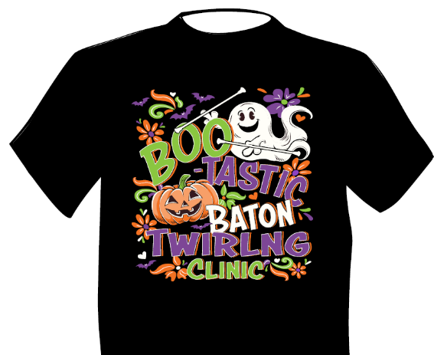
Boo-tastic Baton Twirling Clinic
ORDER FORM
Sponsored by
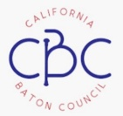
$20.00 ea.
DEADLINE FOR T-SHIRT ORDER 9/23/26

Submitted by
Phone
Email
Address
City/State/Zip

Item | Description | Size |  | Quantity | Unit Price | Amount
Item | Description | Adult/Youth | S/M/L/XL/xx/XXX | Quantity | Unit Price | Amount
 |  |  |  |  | Total
Payment
Zelle: ca.baton.council@gmail.com

